Photography Composition
The reason I am presenting this subject is to help you build and organize your thoughts BEFORE shooting takes place. There are many psychological principals of composition that make sense of chaos and help us organize visual space. Think of it as translating our 3D world into 2D. Your goal is to control and direct the viewer’s attention to what you see as the main subject(s). Plan with intent to set up and take better photos.
In this handout, you will learn to see how shape, line and color work together to create powerful, dynamic compositions. The interplay between your subject and the rest of the frame can be influenced in many different ways.
Try to become more observant! Sherlock Holmes used to tell his assistant, Watson: “Watson, you see but you do not observe”. Let’s all try to observe things you would normally ignore.
I also hope you will find new ways to challenge your photographic creativity. Photographic creativity is about NOT imitating others. It is about being original. But keep in mind that all of today’s photographers depend to some extent on being inspired by what other photographers have done. For ideas, look at the work of our RPC club members for inspiration and then put your own stamp on it.
There are many elements of composition so I’m only touching on 20 from a professional Photographer I found online. I encourage you to research for more information on this subject as you become more proficient in your skills.
It’s been said ”When it comes to composition, the essential ingredients are angle, crop and background”. Do you agree?
Did you know that COMPOSITION is referred to as the 3rd leg of the photographic triangle?
Pop quiz…what are the other two “legs”? (Answer: Light and Subject)
A few years back I attended a seminar put on by Moose Peterson. Here are a few takeaways from that presentation:
- Do the dance…move around to get different framing options.
- Embrace failure…it leads to constant growth.
- Go early…stay late.
- Always look behind you.
- Background is EVERYTHING.
- The worst weather can tell the best stories.
- Don’t take crappy pictures.
- Have fun and make it your passion.
On the following pages, we get a first-hand lesson on composition from Barry Carroll, a professional photographer from Dublin, Ireland.
First of all, we have to define what is meant by ‘composition’. Composition refers to the way the various elements in a scene are arranged within the frame. These are not hard and fast rules but guidelines. That said, many of them have been used in art for thousands of years and they really do help achieve more attractive compositions. I hope you will find that you can have one or more of these guidelines in the back of your mind as you are setting up a shot.

#1. Rule of Thirds
So I’ve just told you that there are no hard and fast rules when it comes to composition and then the first thing I tell you about is the ‘rule’ of thirds. In my defense, I didn’t come up with the name. The rule of thirds is very simple. You divide the frame into 9 equal rectangles, 3 across and 3 down as illustrated below. Many camera manufacturers have actually included the capability to display this grid in live view mode. Check your camera’s manual to see how to turn on this feature.
The idea is to place the important element(s) of the scene along one or more of the lines or where the lines intersect. We have a natural tendency to want to place the main subject in the middle. Placing it off-center using the rule of thirds will more often than not lead to a more attractive composition.
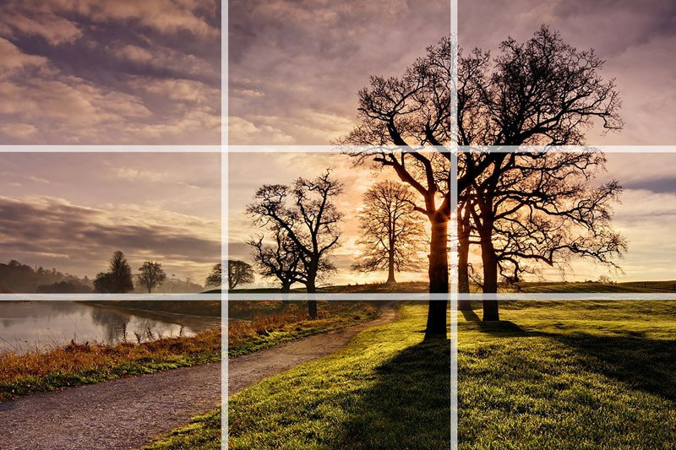
In this photo, I’ve placed the horizon roughly along the bottom third of the frame and the biggest and closest trees along the line to the right. The photo wouldn’t have the same impact if the larger trees had been placed in the center of the frame.

#2. Centered Composition and Symmetry
Now that I’ve told you not to place the main subject in the center of the frame, I’m going to tell you to do the exact opposite! There are times when placing a subject in the center of the frame works really well. Symmetrical scenes are perfect for a centered composition. They look really well in square frames too.
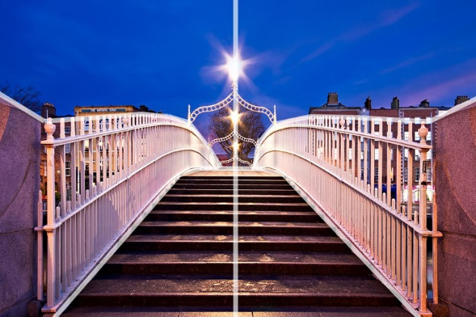

This photo of the Ha’penny Bridge in the city of Dublin was the perfect candidate for a centered composition. Architecture and roads often make great subjects for centered compositions.
Scenes containing reflections are also a great opportunity to use symmetry in your composition.
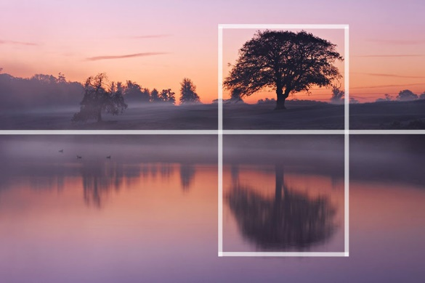
In this photo, I’ve actually used a mix of the rule of thirds and symmetry to compose the scene. The tree is positioned off-center to the right of the frame but the perfectly still water of the lake provides the symmetry. You can often combine several composition guidelines in a single photograph.

#3. Foreground Interest and Depth
Including some foreground interest in a scene is a great way of adding a sense of depth to the scene. Photographs are 2D by nature. Including foreground interest in the frame is one of a number of techniques to give the scene a more 3D feel.
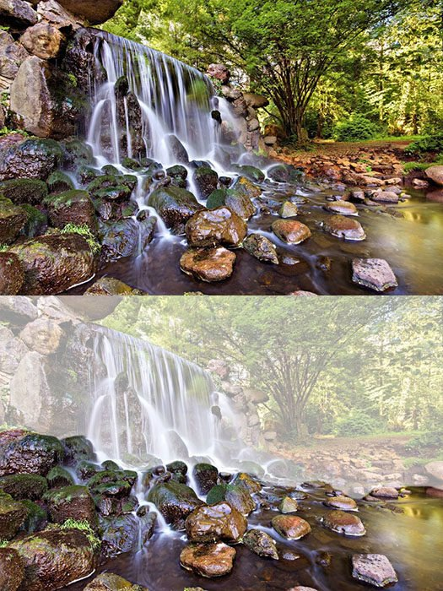
In this photograph of a waterfall in The Netherlands, the rocks in the river provided a perfect source of foreground interest. Adding foreground interest works particularly well with wide-angle lenses.

#4. Frame Within the Frame
Including a ‘frame within the frame’ is another effective way of portraying depth in a scene. Look for elements such as windows, arches, or overhanging branches to frame the scene with. The ‘frame’ does not necessarily have to surround the entire scene to be effective.
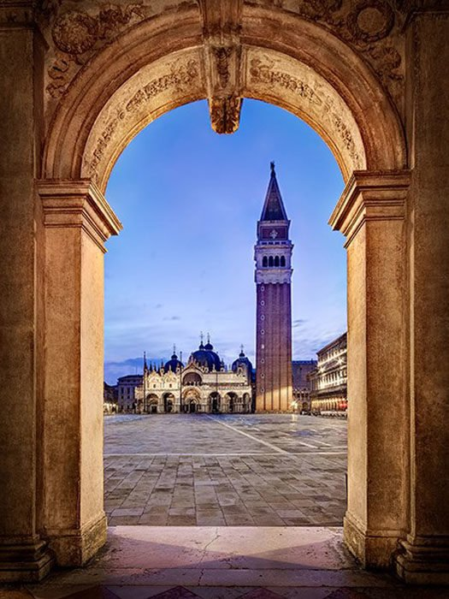
In the photo above taken on St Mark’s Square in Venice, I used the archway to frame St Marks Basilica and the Campanile at the far end of the piazza. The use of scenery viewed through arches was a common feature of Renaissance painting as a way of portraying depth. Frames don’t have to be man-made objects such as arches or windows.
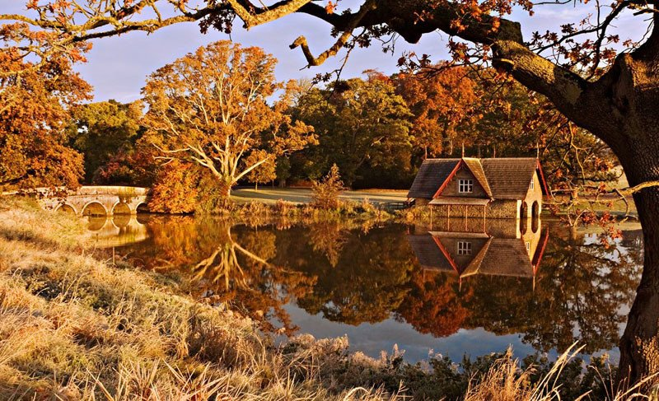
Natural features such as trees can also be used to frame a scene. In this case, the Autumn trees frame the stone bridge. In this case, I also used a centered composition with the bridge in the middle of the frame. Note that the frame doesn’t necessarily have to completely surround your subject. It could be trees on either side, as is the case here. Using a ‘frame within a frame’ presents a great opportunity to use your surroundings to be creative in your compositions.

#5. Leading Lines
Leading lines help lead the viewer through the image and focus attention on important elements. Anything from paths, walls, or patterns can be used as leading lines. Take a look at the examples below.
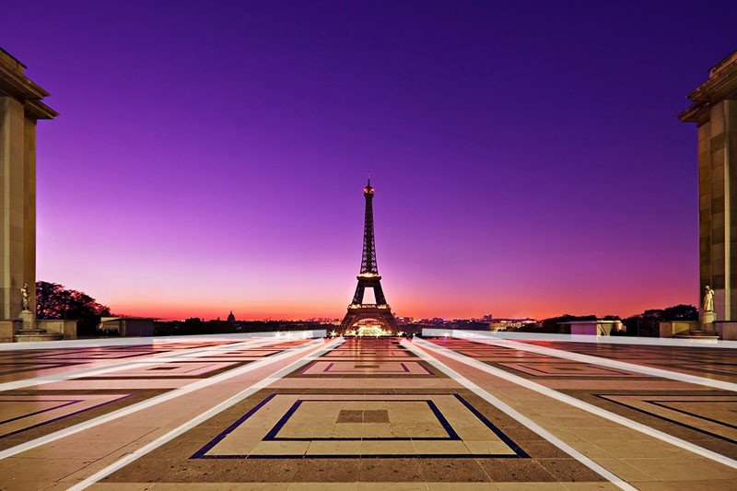
In this photo of the Eiffel Tower, I used the patterns on the paving stones as leading lines. The lines on the ground all lead the viewer to the Eiffel Tower in the distance. You’ll also notice that I used a centered composition for this scene. The symmetry of my surroundings made this type of composition work well.
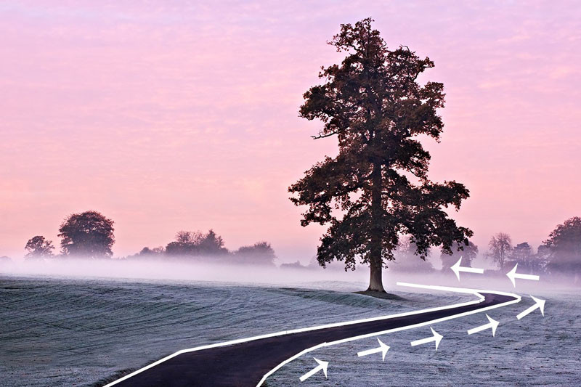
Leading lines do not necessarily have to be straight as illustrated by the picture above. In fact, curved lines can be very attractive compositional features. In this case, the path leads the viewer to the right of the frame before swinging into the left towards the tree. I also made use of the rule of thirds when composing the shot.

#6. Diagonals and Triangles
It is often said that triangles and diagonals add ‘dynamic tension’ to a photo. What do we mean by ‘dynamic tension’ though? This can be a tricky one to explain and can seem a bit pretentious. Look at it this way, horizontal lines and vertical lines suggest stability. If you see a person standing on a level horizontal surface, he will appear to be pretty stable unless he’s stumbling out of a pub at 2 am. Put this man on a sloping surface and he’ll seem less stable. This creates a certain level of tension visually. We are not so used to diagonals in our everyday life. They subconsciously suggest instability. Incorporating triangles and diagonals into our photos can help create this sense of ‘dynamic tension’.
Incorporating triangles into a scene is a particularly good effective way of introducing dynamic tension. Triangles can be actual triangle-shaped objects or implied triangles.
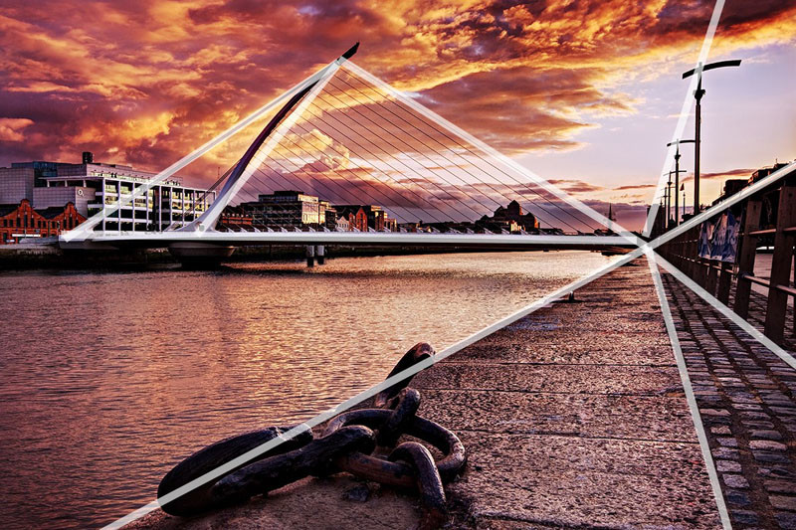
This picture of the Samuel Beckett Bridge in Dublin incorporates plenty of triangles and diagonals into the scene. The bridge itself is an actual triangle (It’s actually supposed to represent a Celtic Harp on its side). There are also several ‘implied’ triangles in the scene. Notice how the leading lines on the right of the frame are all diagonal and form triangles that all meet at the same point. These are ‘implied triangles’. Having diagonals going off in different directions adds a lot of ‘dynamic tension’ to the scene. Once again you can see how I have combined two techniques to compose the image: leading lines and diagonals.

#7. Patterns and Textures
Human beings are naturally attracted to patterns. They are visually attractive and suggest harmony. Patterns can be man-made like a series of arches or natural like the petals on a flower. Incorporating patterns into your photographs is always a good way to create a pleasing composition. Less regular textures can also be very pleasing to the eye.
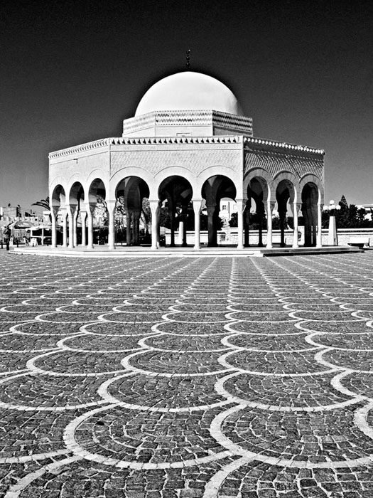
The photo above was taken in Tunisia. I’ve used the pattern in the paving stones to lead the eye to the domed building. The building itself incorporates a pattern in the form of a series of arches.

#8. Break the Pattern
Sometimes using a pattern in your composition means breaking the pattern. This was actually suggested to me in one of the comments of the last article I wrote on composition.
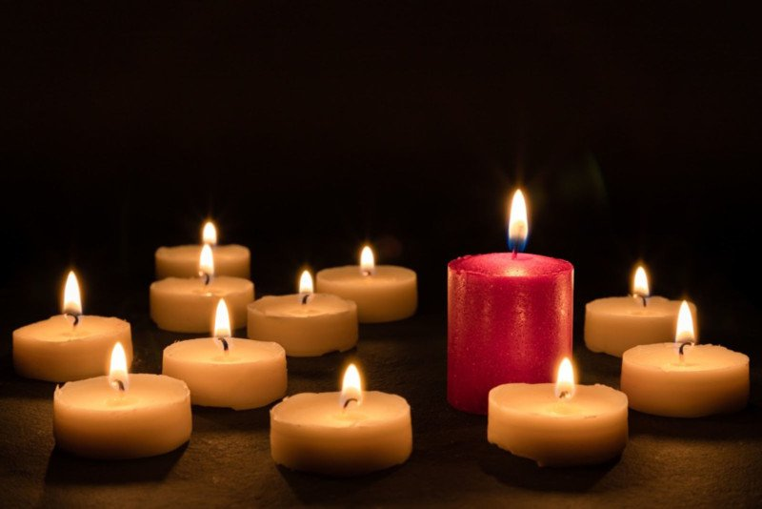
I’ve already said that some “rules” are there to be broken. The same goes for patterns. Breaking the pattern can really make your photograph pop. In this case, the single red candle really stands out among the vanilla-colored ones. It’s also slightly taller than the others which is another way of breaking the pattern. Notice how the photograph still follows the rule of thirds.

#9. Rule of Odds
In the world of photography, there are certainly plenty of ‘odds’ but the ‘rule of odds’ is something different entirely. The rule suggests that an image is more visually appealing if there are an odd number of subjects. The theory proposes that an even number of elements in a scene is distracting as the viewer is not sure which one to focus his or her attention on. An odd number of elements is seen as more natural and easier on the eye. To be honest, I think there are plenty of cases where this is not the case but it is certainly applicable in certain situations.
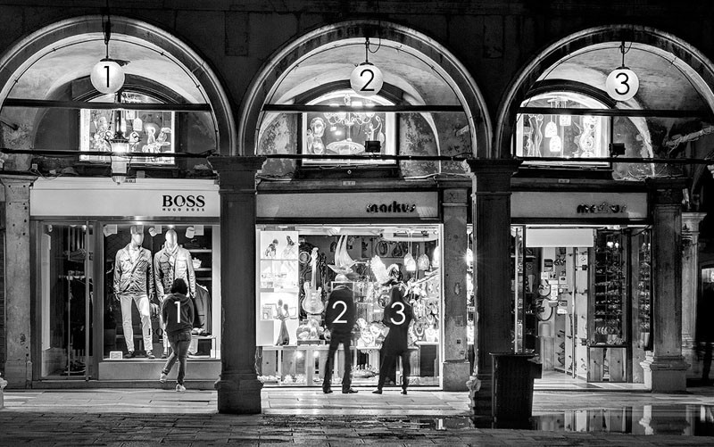
The photo above is an example of the rule of odds. I deliberately framed the scene to include three arches. I think that two arches would not have worked as well and may have divided the viewer’s attention. It also so happened that there were three people in the scene. This composition also makes use of patterns and ‘frames within a frame’.

#10. Fill the Frame
Filling the frame with your subject, leaving little or no space around it can be very effective in certain situations. It helps focus the viewer completely on the main subject without any distractions. It also allows the viewer to explore the detail of the subject that wouldn’t be possible if photographed from further away. Filling the frame often involves getting in so close that you may actually crop out elements of your subject. In many cases, this can lead to a very original and interesting composition.
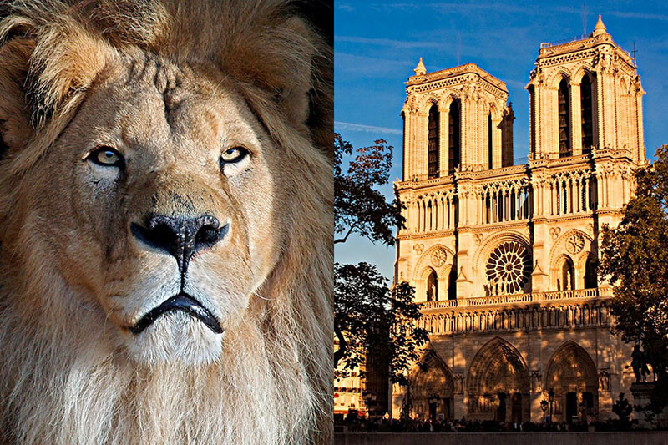
In the photo of the cat on the left, you’ll notice that I filled the frame completely with his face, even cropping out the edges of his head and mane. This allows the viewer to really focus on details such as the eyes or the textures in his fur. You may also notice that I used the rule of thirds in this composition.
In the second shot of Notre Dame Cathedral in Paris, I have left very little space around the edges of the building. the point of this photograph is to showcase the architectural detail of the front façade of the building. In this photo, Notre Dame Cathedral and the adjacent buildings almost completely fill the frame. This allows us to explore details such as the flying buttresses, the stonework, or the ornate balconies on the building next door. It is a scene where the eye wanders around the frame.

#11. Leave Negative Space
Once again, I am going to completely contradict myself! In the last guideline, I told you that filling the frame works well as a compositional tool. Now I’m going to tell you that doing the exact opposite works well too. Leaving a lot of empty or ‘negative’ space around your subject can be very attractive. It creates a sense of simplicity and minimalism. Like filling the frame, it helps the viewer focus on the main subject without distractions.
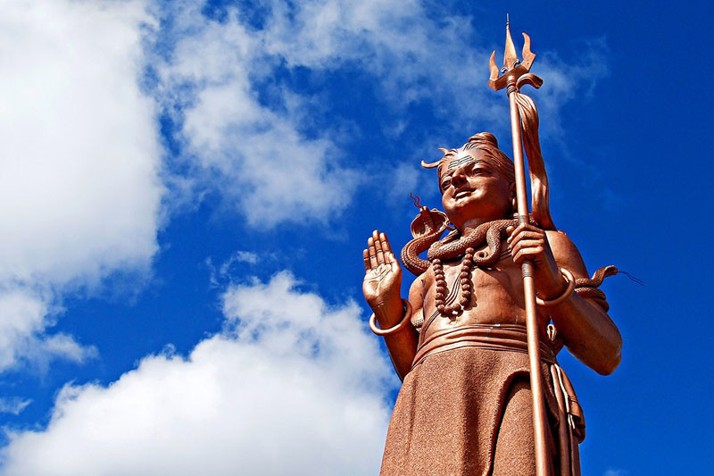
This photo of a giant statue of the Hindu god Shiva in Mauritius is a good example of using negative space. The statue is obviously the main subject but I have left plenty of space filled only by sky around it. This focuses our attention on the statue itself while giving the main subject ‘space to breath’ so to speak. The composition also creates a sense of simplicity. There is nothing complicated about the scene. It is the statue surrounded by sky, that is all. I also used the rule of thirds to place the statue to the right of the frame.
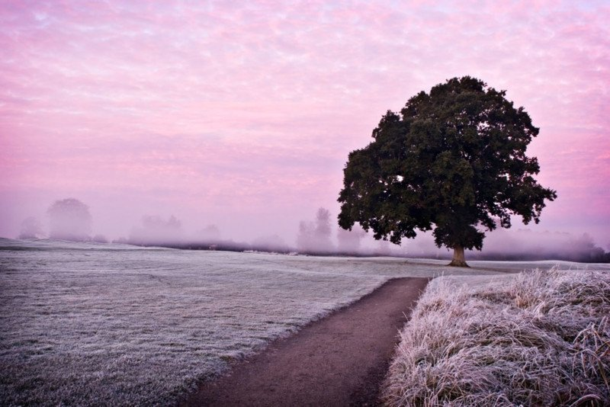

This simple landscape photograph makes use of negative space. The misty morning actually helped obscure some of the background elements making the tree on the left really stand out with little to distract from it.

#12. Simplicity and Minimalism
In the last guideline, we saw how leaving negative space around the main subject can create a sense of simplicity and minimalism. Simplicity itself can be a powerful compositional tool. It is often said that ‘less is more’. Simplicity often means taking photos with uncomplicated backgrounds that don’t distract from the main subject. You can also create a simple composition by zooming in on part of your subject and focusing on a particular detail.
In this photo, I zoomed in on some water droplets on a leaf in a garden. It’s such a simple subject but is also very beautiful because of its simplicity. A good macro lens can be a very useful tool for creating these types of photos.

#13. Use Black and White
Converting a photograph to black and white can be a very effective method of simplifying your composition. In some ways, color itself can be a distraction. Black and white photography often allows us to focus on the textures, light, shadows, and shapes in the frame. Take a look at the following photographs taken along the Copper Coast in County Waterford, Ireland.
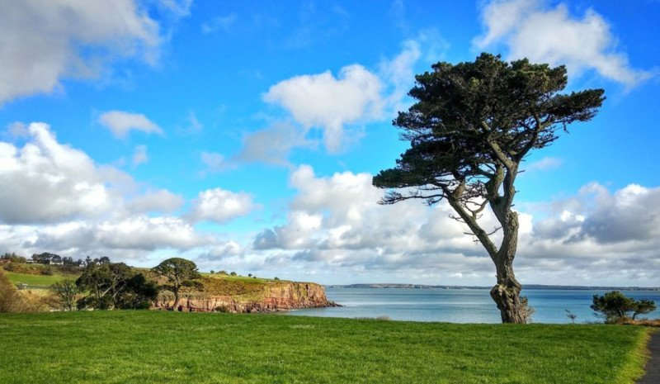

The light in this version actually isn’t all that interesting. It’s that harsh daytime light that is rarely conducive to spectacular landscape photography. The location itself has potential though. Let’s see what happens when we convert this image to black and white.

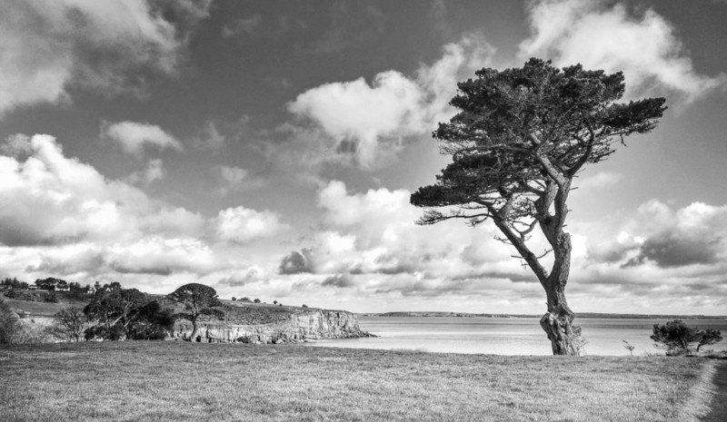

With the “distraction” of color removed, I think this becomes a much stronger shot. That harsh light now helps to highlight the textures on the tree, in the grass, on the cliffs, and in the sky. The bold shape of the tree stands out against the sky and the scattered clouds in the sky look more dramatic. The color was hiding much of this in my opinion. Not every shot is suited to a black and white conversion but in this case, I think it was.

#14. Isolate the Subject
Using a shallow depth of field to isolate your subject is a very effective way of simplifying your composition. By using a wide aperture, you can blur the background that might otherwise distract from your main subject. This is a particularly useful technique for shooting portraits.

In this photo of a cat hiding in a box, I set an aperture of f/3.5 which is very wide and results in a very blurred background. This focuses attention on the cat as the blurred background is now less distracting. This technique is an excellent way to simplify a composition. You may have noticed that I also used this technique to focus attention on the water droplets on the leaf in the last guideline.

#15. Shoot from Below
The vast majority of photographs are taken from head height. Getting down low or up high can be a great way of capturing a point of view that is more dynamic or interesting. I have often seen wildlife photographers lying on their bellies to get that special shot.
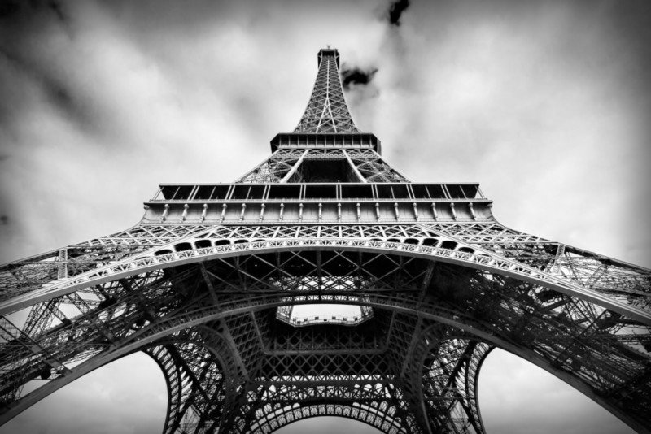
I took this photograph of the Eiffel Tower while standing at its base and pointing my camera up. This was also a perfect occasion to use a centered composition due to the symmetrical subject. It means I have a photo that’s a little different from the majority of shots of this Parisian landmark.

#16. Shoot from Above
Whenever I visit a new location, I like to get high at least once. I also like to take photographs from a high vantage point at some point during my trip. Before my trip, I always research the possibilities to take some bird’s eye photos. Most cities and towns usually have a high building or bell tower you can climb to get some shots from high above your surroundings. Just make sure they allow tripods if you plan to bring one.
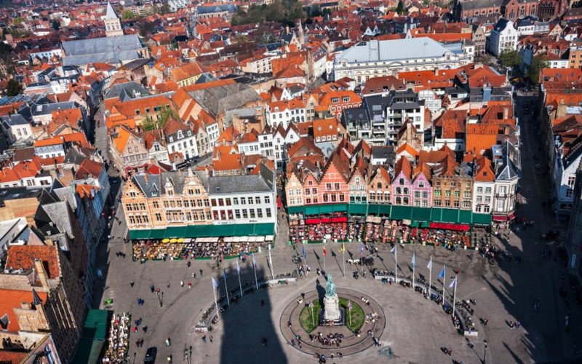
I had to work extremely hard to get this shot of Market Square in the heart of Bruges. For a start, I had to lug my camera gear up 366 narrow steps to the top of the Belfry. I actually met a guy whose office was right at the top of the belfry. He told me that he made the trip up and down the tower several times a day in a suit and dress shoes. Whereas I looked like I’d just climbed Everest; he barely broke a sweat.

#17. Look for Particular Color Combinations
The use of color itself is an often overlooked compositional tool. Color theory is something that graphic designers, fashion designers, and interior designers are all very familiar with. Certain color combinations complement each other well and can be visually very striking.
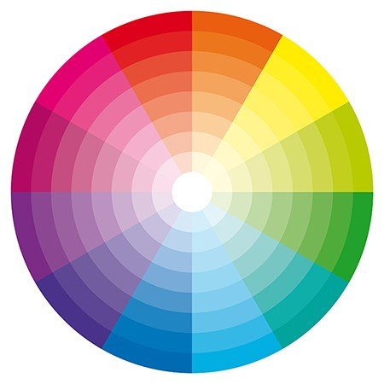
Take a look at the color wheel above. You can see that the colors are arranged logically in the segments of a circle. Colors that are opposite each other on the color wheel are said to be ‘complimentary colors’. As photographers, we can look for scenes that incorporate complementary colors as a way of creating attractive and striking compositions.
Have you ever noticed how many movie posters have blue and yellow/orange color schemes? This is done quite deliberately to create eye-catching adverts.
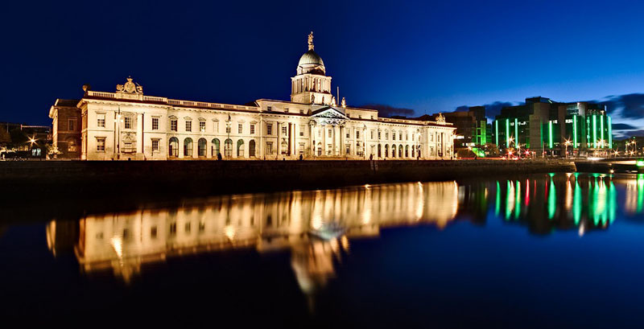
I made use of the striking blue/yellow color combination myself in this photograph of the Custom House in Dublin. The yellow hues of the illuminated building contrast beautifully with the deep blue of the blue hour sky.
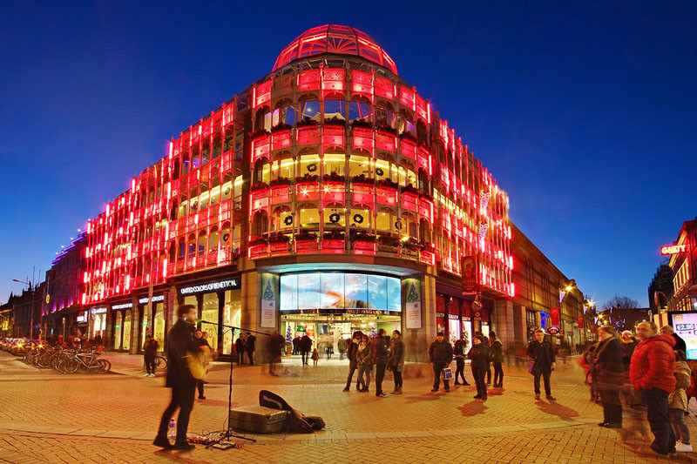

Red and blue are also complimentary colors on the color wheel. The Stephen’s Green Shopping Center in Dublin was lit up red for Christmas last year. This was very striking against the deep blue of the early night sky. I love photographing cities during blue hour. The deep blue of the sky at this time provides a very attractive backdrop to the city’s architecture and lights. The pure black of the late-night sky is not as striking and contrasts too sharply with the lights of the city.

#18. Rule of Space
The rule of space relates to the direction the subject(s) in your photo is facing or moving towards. If you are taking a photo of a moving car, for example, there should be more space left in the frame in front of the car than behind it. This implies that there is space in the frame for the car to move into. Take a look at the example of the boat below.
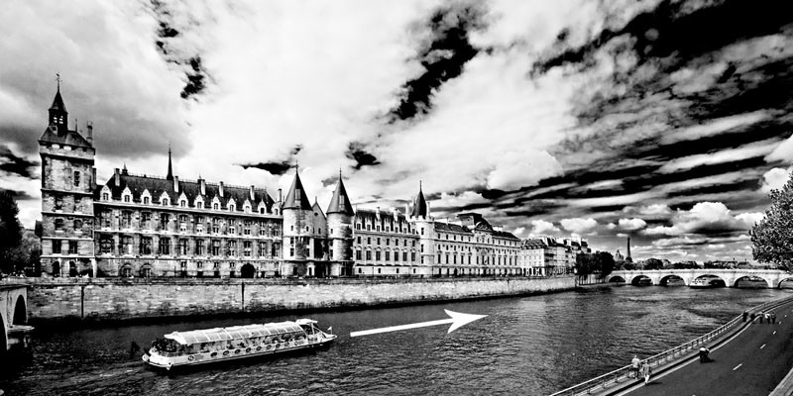
In this photo, the boat is placed on the left-hand side of the frame as it moves from left to right. Notice how there is a lot more space for the boat to move into in front of its direction of motion (to the right) than behind it. We can mentally imagine the boat moving into this space as it sails along the river. We also have a subconscious tenancy to look forward to where an object is heading. If the boat was right up at the right-hand side of the frame, this would lead us out of the photograph!
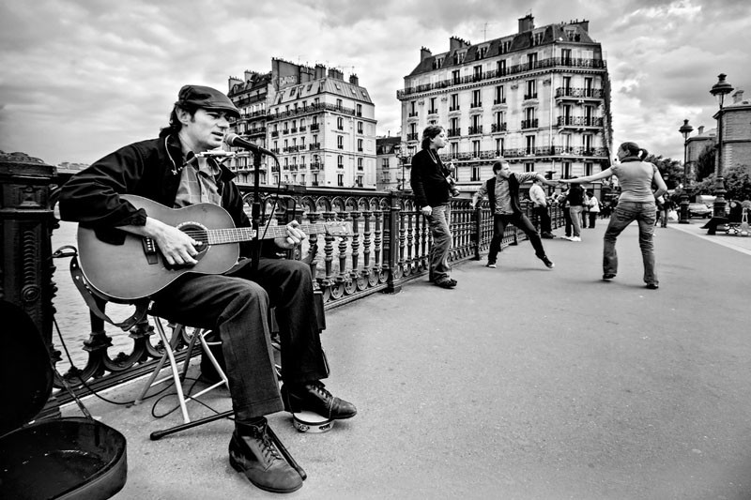
This can also be used for pictures of people. The rule of space suggests that the subject should be looking or facing into the frame rather than out of it. Take a look at the musician in the photo above. I composed the shot with him sitting on the left-hand side of the frame. He is facing to the right (as we look at him) into the area of space between him and the right-hand edge of the frame. If he had been facing the other way, he would be looking out of the frame and this would look odd. By looking into the space in the frame, he leads our eye past the man leaning on the railing and to the couple dancing on the right-hand side.

#19. Left to Right Rule
There is a theory that says we ‘read’ an image from left to right in the same way we would read text. For this reason, it is suggested that any motion portrayed in a photograph should flow from left to right. This is all very well but it assumes the viewer is from a country where text is read from left to right. Many languages are read from right to left such as Arabic for example. To be honest, I’ve seen plenty of fantastic photographs that ‘flow’ from right to left.
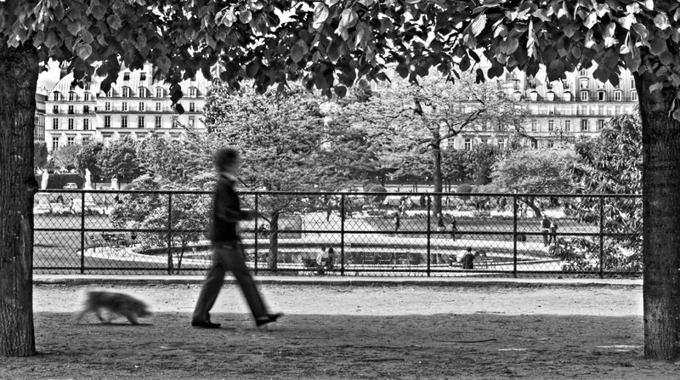
The photo above follows the ‘left to right’ rule. The woman walking her dog in the Tuileries Garden in Paris is walking from the left to the right of the frame.

#20. Balance Elements in the Scene
The first compositional guideline we looked at in this tutorial was the Rule of Thirds. This of course means that we often place the main subject of the photo to the side of the frame along one of the vertical grid lines. Sometimes this can lead to a lack of balance in the scene. It can leave a sort of ‘void’ in the rest of the frame.
To overcome this, you can compose your shot to include a secondary subject of lesser importance or size on the other side of the frame. This balances out the composition without taking too much focus off the main subject of the photograph.
Take a look at this photograph of the ornate lamppost on the Pont Alexandre III in Paris.
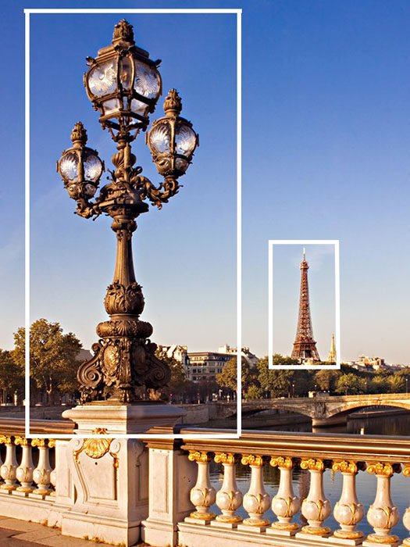
The lamppost itself fills the left side of the frame. The Eiffel Tower in the distance counterbalances this on the other side of the frame.
You may have remarked that this seems to go against the idea of negative space mentioned in guideline number 10. It also contradicts the ‘rule of odds’ as we now have an even number of elements in the scene. As I said at the very beginning of this tutorial, there are no unbreakable rules in photographic composition. Some of these guidelines contradict each other and that’s ok. Some guidelines work well for certain types of photographs and not others. It’s a question of judgment and experimentation.
About the author: Barry O Carroll is a Dublin, Ireland-based photographer specializing in landscape photography with a particular emphasis on urban landscapes, street scenes and architecture photography. You can find more of his work on his website or by following him on Facebook and Twitter. Submitted by Patty Van Stone, March 2022

